Evergreen Park Cooking Show

Design Brief:
You are the hosts of the Evergreen Park “Fun with Food” cooking show and have been asked to produce a special episode on how to make a gourmet pizza. Your group will be responsible for choosing ingredients, making the pizza, and creating a “Windows Movie Maker” video show.
Student Objectives:
- Understand the steps and terms required to follow a recipe in the process of making pizza
- Learn how to accurately measure ingredients
- Collaborate in planning a sequential story outline for the instructional video
- Understand how to properly use a digital camera
- Photograph the preplanned sequential steps while the pizza is being created
- Demonstrates knowledge of food and kitchen safety
- Follow proper etiquette procedures in setting a table and eating your pizza
- Learn the procedure in downloading and resizing pictures using “Microsoft Office Picture Manager”
- Follow the steps in a Windows movie maker tutorial to prepare for the creation of the final cooking show.
- Create and narrate the cooking show episode using “Windows Movie Maker”
- Finalize the show and notify the teacher
Item Values:
 | Item | Description | Value
Part A | Research:  Terms | Define basic cooking terms and list important practices with regards to food/kitchen safety and proper etiquette | 10%
Part B | Planning: Movie Outline | Fill in the movie outline sheet with sequential picture descriptions and corresponding narration | 20%
Part C | Making:  Make pizza, set table, eat pizza | Make the Pizza and take necessary pictures (you will be marked on your work habits and appropriate behaviors) | 10%
Part D | Resize Pictures | Using “Microsoft Office Picture Manager” resize pictures to 600X800 | 10%
Part E | Movie Maker Tutorial | Follow the outlined procedure to complete the sample “Windows Movie Maker” tutorial. | 10%
Part F | Produce Movie | Using your newly acquired skills in “Windows Movie Maker” produce your Cooking show. | 40%

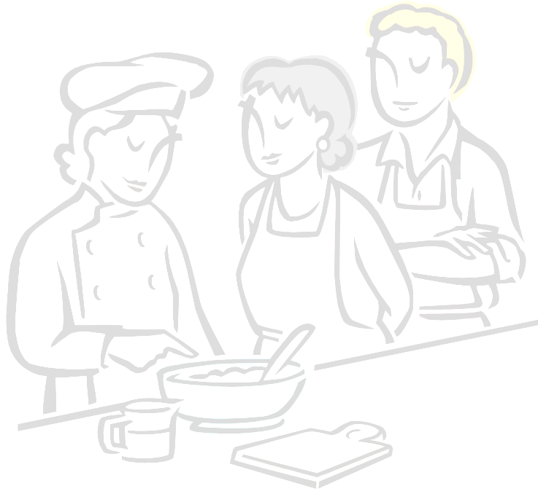

Part A: Research
Basic Cooking Terms Value 10%
I. On the prepared sheet define the following terms in your own words:
- Beat |  | 6.Combine
- Knead |  | 7. Sauté
- Cream |  | 8. Season
- Dice |  | 9. Simmer
- Pare |  | 10. Slice
- Illustrate the proper place setting of a fork, knife, spoon, plate, glass and napkin.
- List 5 food or kitchen safety practices relevant to this project.

Part B: Planning
Sequential Movie Outline Value 10%
Using the “Movie outline sheet” provided, organize the steps of your movie and fill in the sequential picture descriptions with its corresponding narration. See the example below:
Steps | Picture Description | Corresponding Narration
Title Frame: | “Cooking with Bill and Betty” | Bill and Betty-“Welcome tooooooo….Cooking with Bill and Betty. Join us as we take you on a culinary adventure to Pizza land.”
Intro | Picture of Bill | Bill-“Hi, I’m Bill”
Intro | Picture of Betty | Betty-“and I’m Betty”
Intro | Picture of Bill and Betty | Bill-“Today we will be demonstrating the steps in preparing a gourmet homemade pizza.”  Betty- “Following that we will give you some tips in dining etiquette, so sit back and enjoy the show.”
Turn on the oven | Close up picture of Betty setting the oven to the proper temperature, making sure the numbers on the dial are visible. | Betty- “It is important to preset your oven to the correct temperature so it is ready for baking when you finish preparing your pizza.
Next step
Next step
Closing Credits | Cooking with Bill and Betty  Produce by  Bill MacDougal  Photos by  Betty Wright and Bill MacDougal  Directed by  Betty Wright | Background music …”Highway blues”

Part C: Making
Make Pizza, Set Table, Eat Pizza Value 10%
Remember: Photos are taken throughout these steps. Be sure to refer to your planning outline.
Recipe: Thin Crust Pizza Dough
- 1 envelope of dry yeast (1 tablespoon) 15 ml
- ¼ teaspoon of sugar 1 ml
- ¾ cup of lukewarm water 180 ml
- 1 ¾ cups of white flour (240+180) 420 ml
- ½ teaspoon of salt 2 ml
Step by step procedure:
- Wash hands and set up the work area with all necessary ingredients and equipment.
  - Combine 1 envelope (1 tablespoon) of dry yeast, ¼ teaspoon of sugar and ¾ cups of lukewarm water in the glass measuring cup. Mix a little and let sit for 6-8 minutes.
  - Combine 1 ¾ cups of flour with ½ teaspoon of salt in a bowl.
  - Pour the water combination into the bowl and mix with a spoon until you have a neat ball.
  - Prepare a lightly sprinkled surface with flour. Turn out dough and knead for around 2-3 minutes. To knead, pick up the far edge of the dough and fold over the bottom edge. Press down with the heels of your hands, pushing the dough away from you. Turn the dough one quarter of a turn and repeat the process. When properly kneaded, dough will be smooth and satiny stretchy and no longer sticky.
  - Grease the pizza pan with shortening.
  - Place dough on center of pan and press out with hands creating a thicker crust along edge.
  - Using large spoon, spread sauce over crust being careful not to get any on the crust.
  - Add your chosen toppings (these will be chopped/sliced as necessary using cutting board).
  - Cover/sprinkle pizza with grated mozzarella cheese (approx. 1 cup)
  - If not cooking the pizza today, you will need to wrap your pizza with aluminum foil, label with your names (masking tape) and place in the freezer. Pizza will be thawed, cooked and eaten next class.
  - Cook in pre-heated oven at 450 degrees for about 16-18 minutes or until crust is golden brown and cheese is bubbly.
  - While pizza is cooking, you should clean your work area, wash dishes and set table. See “Etiquette Everyday” for Basic Place Setting format.
  - Enjoy your pizza !!

You will be graded based on an observation checklist of your work habits and performance in the kitchen.
Pictures need to be imported into computers on the day they are taken and saved/resized in a labeled file in your U drive. Remember: 2 groups are sharing a camera so you’ll need to select only your photos.

Part D: Resizing Pictures Value: 10%
Using Microsoft Office Picture Manager
- Once you have imported your pictures into 1 folder, open the folder and right click on 1 picture. Choose open with Microsoft Picture Manager.
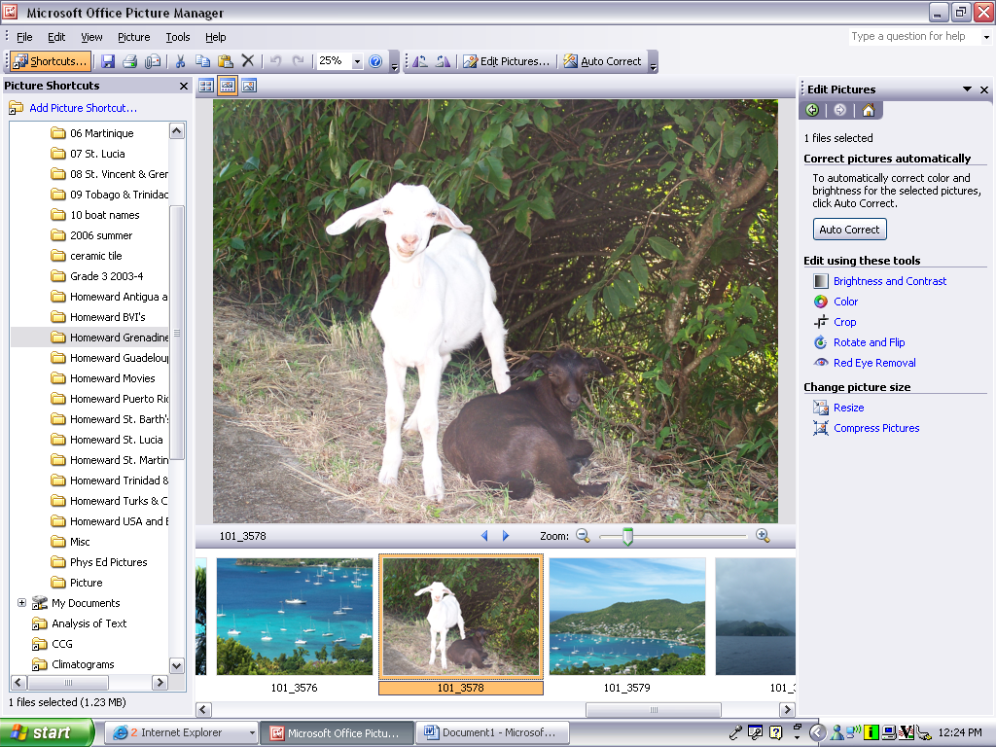
- In order to see all your pictures, choose the square for many clips in the top left hand corner of your screen:
3. Select all these pictures by pressing Ctrl-A. Now you can resize them by selecting Edit Pictures.
many clips on one page,
filmstrip or
a single picture.
In the Task Pane, Choose: Edit Pictures

Click Resize

4. Select Resize and then predefined width and height.
5. Choose 800 x 600 px (document-- Small) and then apply these settings by selecting OK at the bottom of the page.
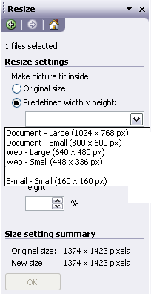
Select “Document-Small”

6. Now, you just need to save this file to your U-drive.

Part E: Windows Movie Maker Tutorial

Please complete the following tutorial save your work and call your teacher over to approve it before moving on with the next step.

Getting Started: To get started you must first open the Program
Launch Movie Maker by going to Start > All Programs > Windows Movie Maker
You will now go step by step to put your show together. The six steps necessary are:
- Importing Pictures
- Creating a title at the beginning
- Creating Credits at the end
- Inserting Transitions between pictures
- Narrating the show
- Saving the show
Step 1: Importing Pictures
A) Import Sample Pictures from file
- Click on “Import pictures” in the Movie Task bar
- Select the four pictures(CTRL-A)from “My Documents→Sample Picture
- Click the Import button
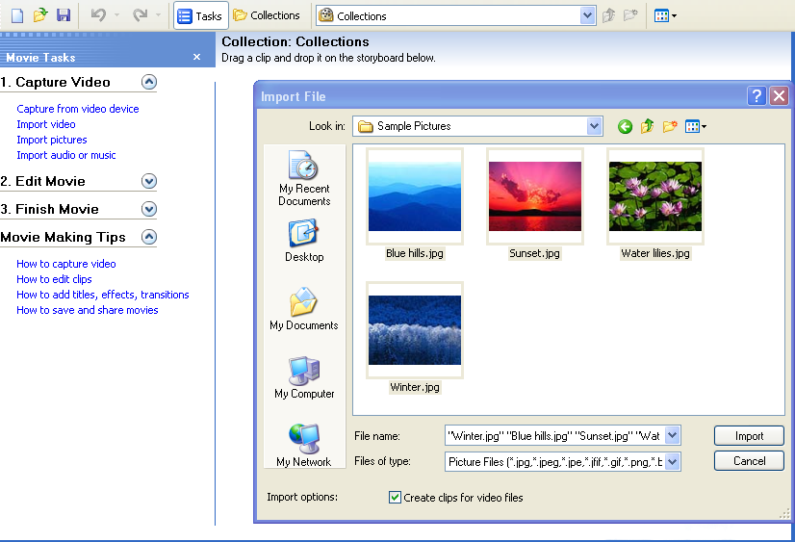

Import Pictures

Select 4 Pictures

Click “Import”

Your Pictures will now be brought into the “Collection window” of Movie Maker
B) Select Pictures and drag them to the Storyboard
- To select all of the pictures in your collection window click on one picture then hold down CTRL and the A key (for ALL)
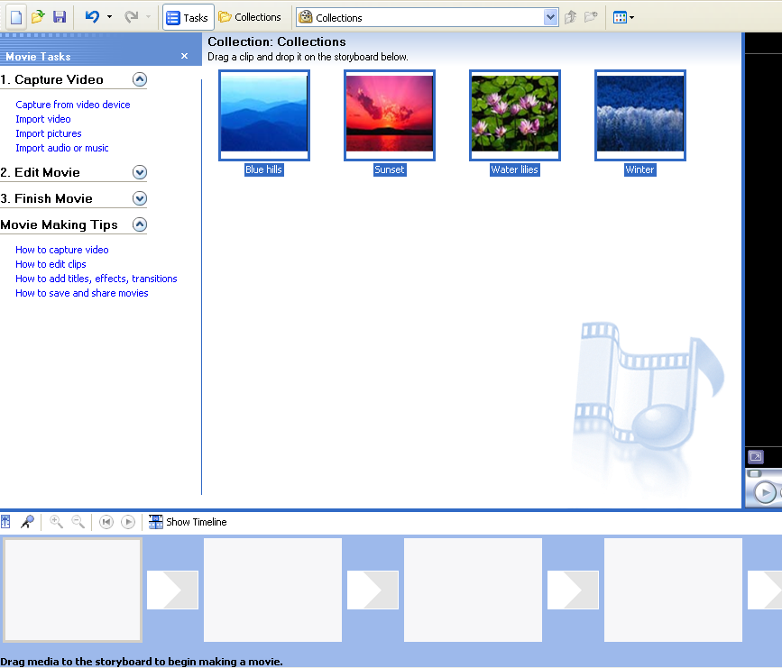
- Next drag and drop the selected pictures to the First square in the storyboard at the bottom of the screen
Click on one picture and press
Ctrl – A on the keyboard

Drag the pictures to the first box in the storyboard

Your Storyboard should now look something like this:
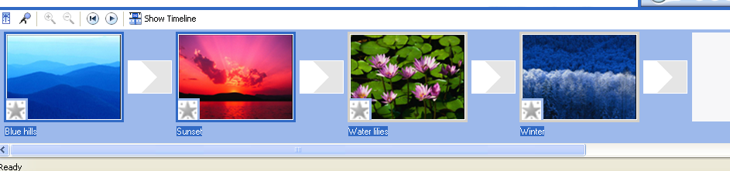

You may now arrange your clips in the correct order by dragging them left or right.

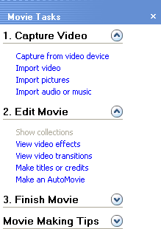
Step 2: Adding a title at the beginning of your show

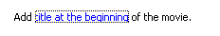
Click on “Make titles or credits”

Step 3: Adding Credits at the end of your show
Still under “Edit Movie,” select add credits and list all the people involved in creating the show and what their roles were.
Step 4: Adding video transitions between pictures in your storyboard.
Now select “View video transitions” in order to choose the way your movie presents each picture you’ve included in your movie. Click and drag the selected transitions to each box between your pictures. You can preview how this looks by clicking the play button on the Preview Monitor.
Step 5: Narrating the Show
On the View menu, click Timeline. Now, go to Tools and select Narrate Timeline. The playback indicator on the timeline must be at a position where the Audio/Music track is empty. You must be in the timeline view.
Capturing an audio narration lets you describe, in your own words and voice, what is displayed in the video, pictures, or titles as the items are shown in your project and, ultimately, in your final saved movie. Narrating the contents of the timeline serves as another way for you to enhance your movie. The following options are displayed when you narrate the timeline:
Start Narration
Click to begin capturing your audio narration to your computer. Make up a description for these pictures. (**When you are creating your Cooking Show, you and your partner(s) will read your preplanned script for your movie to describe each of the steps needed to make your gourmet pizza.)
Stop Narration
Click to stop capturing your audio narration to your computer.
IMPORTANT: When completed, playback your movie to see how it turned out. It is likely that you will need to edit your movie in order for the narration to match each picture. You can click and drag the edge of each photo until it matches the narration. Keep playing back your work in the Preview Monitor until you get it right. This may take some patience but the quality of the movie will depend on it. A 2nd option would be to narrate one picture at a time, stop and save this narration and adjust the picture size to match the length of the narration.
Step 6: Saving the Show
In your task pane under Finish Movie, select Save to my computer.
- Enter your names as the title of your movie
- Browse in order to select your U-drive for the save location.
Then, select Next. Then, again, select Next. Your movie will now save. Select Finish and call the teacher over to watch your movie play back.
Once the teacher has seen your practice movie, you will be instructed to delete this from your file.

Part F: Making the Movie


Movie Maker
Now that you know how Microsoft Movie Maker works, you can repeat these steps in order to create your Fun With Food Cooking Show. Have Fun !!

Each group will present their shows to the class and these will be evaluated by the teacher, yourselves and your peers.

